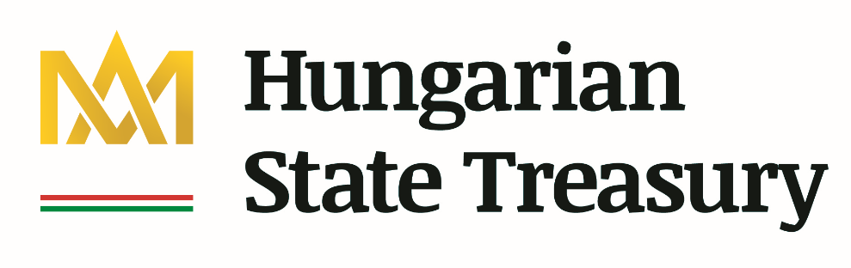

Budapest PUBLIC FINANCE Seminar 2021
„Sustainability of Public Finances”

Thursday 20 May 2021

09.00 – 09.20 WELCOME & OPENING REMARKS

András KOLTAY
Rector, Ludovika–University of Public Service

Csaba BUGÁR
President, Hungarian State Treasury

Session I.
09.20 – 12.25 Moderator: Viktor VÁRPALOTAI

09.20 – 09.45 Richárd ADORJÁN
Deputy State Secretary, Ministry of Finance
Opening speech

09.45 – 10.15 Jean-Marc FOURNIER
International Monetary Fund, Economics Department
Keynote speech: “A Buffer-Stock Model for the Government:
Balancing Stability and Sustainability”

10.15 – 10.35 Silvia FEDELI - Francesco FORTE - Elton BEQIRAJ
Sapienza University of Rome, Department of Economics and Law
“Public debt sustainability: An empirical study on OECD countries"

10.35 – 11.00 Questions and answers

11.00 – 11.25 Break

11.25 – 11.45 Carsten COLOMBIER
Federal Administration of Switzerland
"Healthcare expenditure and fiscal sustainability: evidence from Switzerland"

11.45 – 12.05 Joanna MACKIEWICZ-ŁYZIAK
University of Warsaw, Facutly of Economic Sciences
"Sustainability of Public Finances in European Economies: Fiscal Policy Reactions and Market Pricing"

12.05 – 12.25 Questions and answers

12.25 – 14.00 Break

Session II.
14.00 – 16.20 Moderator: Pál Péter KOLOZSI

14.00 – 14.20 Vladimir ARČABIĆ
University of Zagreb
"Fiscal convergence and sustainability in the European Union"

14.20 – 14.40 Csaba TÓTH G
Hungarian Demographic Research Institute
"Fears and risks about the fiscal impact of population ageing"

14.40 – 15.00 Questions and answers

15.00 – 15.20 Break

15.20 – 15.40 Györgyi NYIKOS – Andrea GALLASZ
Ludovika-University of Public Service, Political Science and International Studies Faculty
“Capital Budgeting in Hungary”

15.40 – 16.00 Gábor KUTASI
Ludovika-University of Public Service, Eötvös József Research Center
Research Institute of Economy and Competitiveness
“Everything Bubble: Record global boom backed by increasing fiscal unsustainability”

16.00 – 16.20 Questions and answers

